1. Project Overview
This project focuses on analyzing customer behavior within a telecommunications dataset to identify the key drivers of customer attrition (churn). By examining demographic information, subscription details, account tenure, and monthly charges, the analysis aims to provide actionable insights into which customer segments are most likely to leave. The ultimate goal is to aid in developing targeted retention strategies for different service providers and regions.
2. Dataset Description
The dataset contains 7,043 unique customer records and 23 features. It includes a mix of categorical (demographic, service details) and numerical (tenure, charges) variables.
- Target Variable: Churn (Indicates if a customer left the service).
- Demographics: gender, SeniorCitizen, Partner, Dependents, Region.
- Services: Service_Provider (Jio, Airtel, Vi, BSNL), PhoneService, InternetService, etc.
- Account Info: tenure, Contract, PaymentMethod, MonthlyCharges, TotalCharges.

Summary for Dataset: Below is the distribution of the most critical columns used in this analysis:
- Total Customers: 7,043
- Churn Status:
  - No (Retained): 5,174 (73.5%)
  - Yes (Churned): 1,869 (26.5%)
- Gender Distribution:
  - Male: 3,555
  - Female: 3,488
  - (The dataset is well-balanced regarding gender).
- Service Providers:
  - Jio: 1716
  - Airtel: 2462
  - Vi: 818
  - BSNL: 2047

3. Visualization Analysis and Interpretation

Exploratory Data Analysis (EDA) was conducted using Matplotlib only, ensuring complete control over visualization design and clear interpretability of results. Each visualization was carefully selected based on its relevance, its ability to reveal meaningful patterns, and its usefulness in understanding customer churn behavior. The EDA focused on identifying key factors influencing churn, analyzing customer behavior across demographic, service, and billing attributes, and uncovering trends related to customer tenure and pricing. These insights guided feature understanding and provided a strong foundation for subsequent modelling and prediction tasks.

- The below plot shows the relation between Gender,citizen,churn
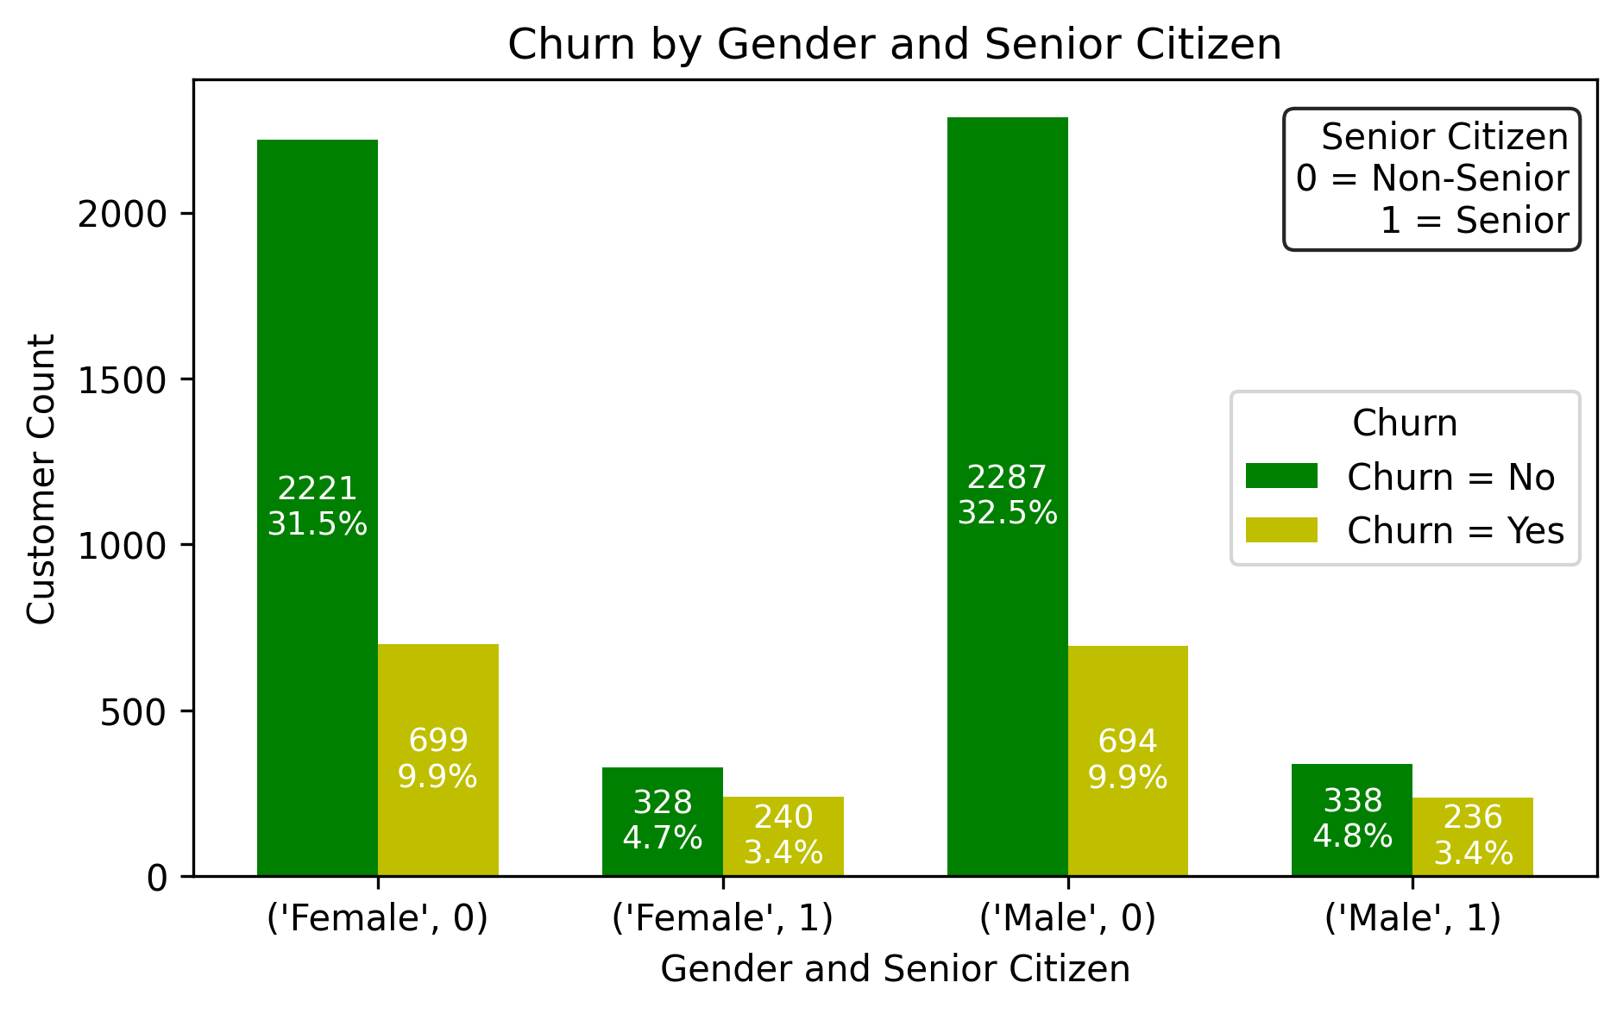
- Total trusted users are 5174(male=2625,female=2549)
- Total churn users are 1869(male=930,female=939
- Total male seniro citizen are 574(churn=236,no churn=338)
- Total male non senior citizen are 2981(churn=694,no churn=2287)
- Total female senior citizen are 568(churn=240,no churn=328)
- Total female non senior citizen are 2920(churn=699,no churn=2221)
- The below plot shows the relation between Phone service,Gender,citizen,churn
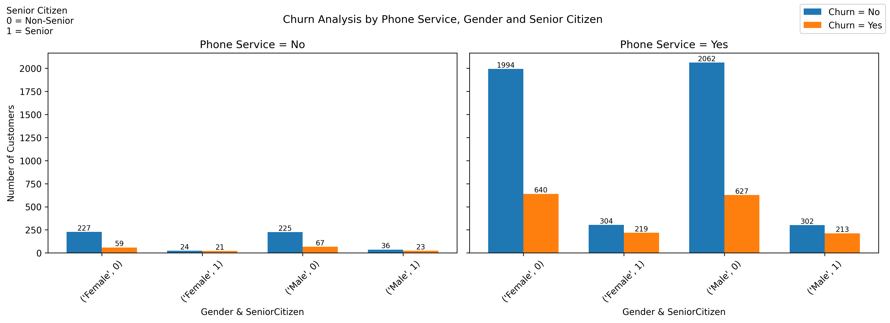
- Most customers have phone service.
- Churn is much higher for customers with have phone service .
- The ratio of churn in senior citizen is high compared to non senior citizen.
- Customers without phone service churn very little.

- The below plot shows the relation between Multiplelines,Gender,churn
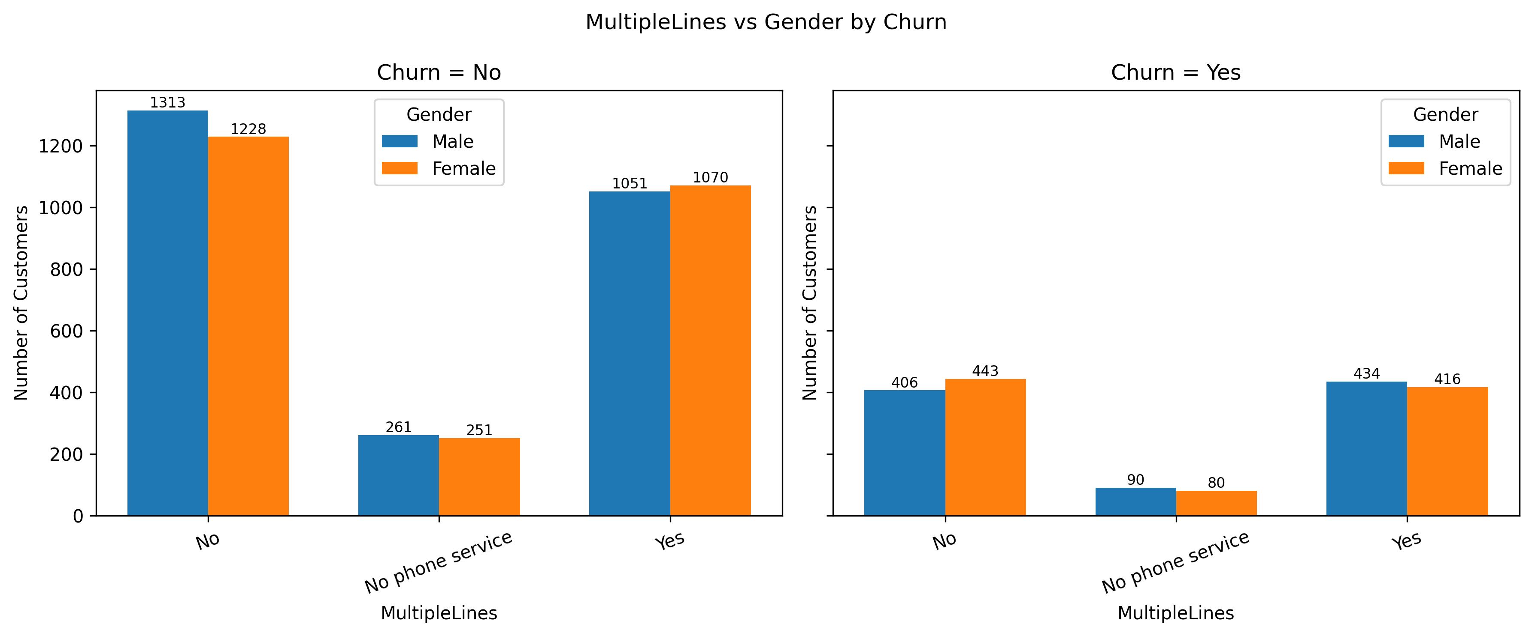
- Most customers do not have multiple lines.
- Customers with No phone service are the smallest group.
- Male and female customers are almost equally distributed across all MultipleLines categories.
- The female is having high chern rate compared to male
- The below plot shows the relation between Internet service,sim
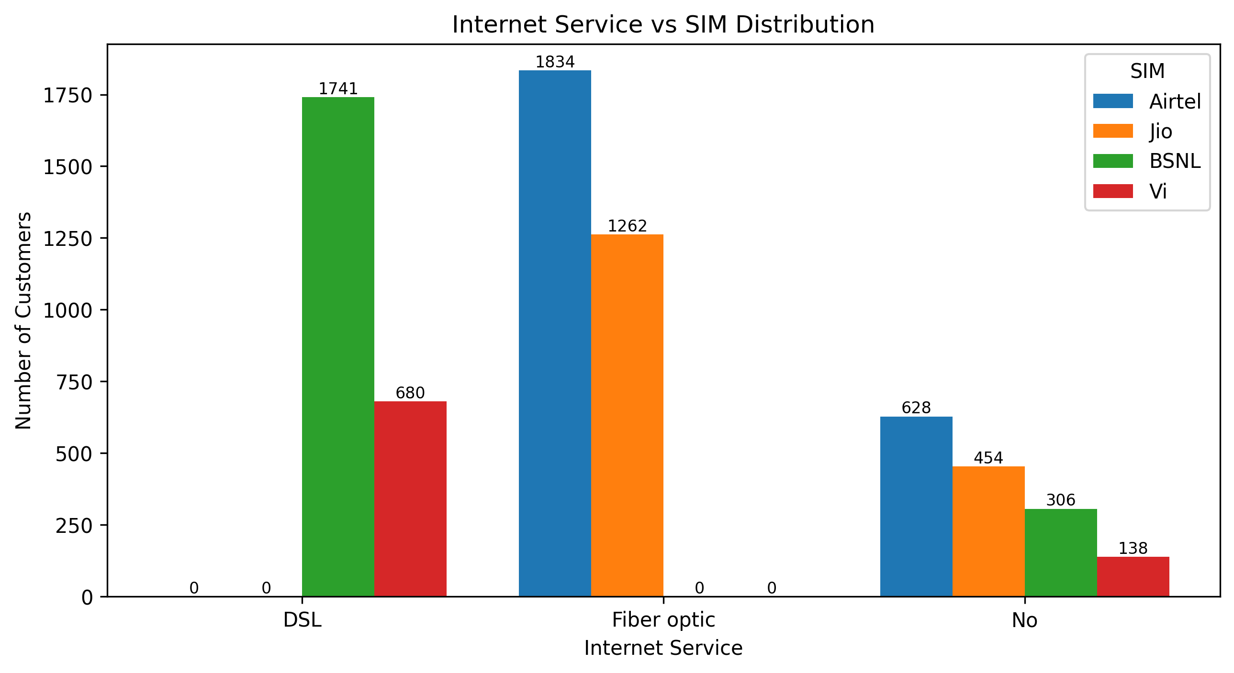
- Fiber optic is the most widely used internet service overall.
- Airtel and Jio dominate in the fiber optic segment.
- BSNL and Vi customers are mainly concentrated in DSL service.
- Customers with no internet service are fewer compared to fiber and DSL users.
- Airtel has the highest customer count across internet services.
- Jio is the second most popular provider, mainly in fiber.
- Customers with no internet service are mostly using Airtel next Jio , BSNL, Vi

- The below plot shows the relation between Sim,Gender,citizen
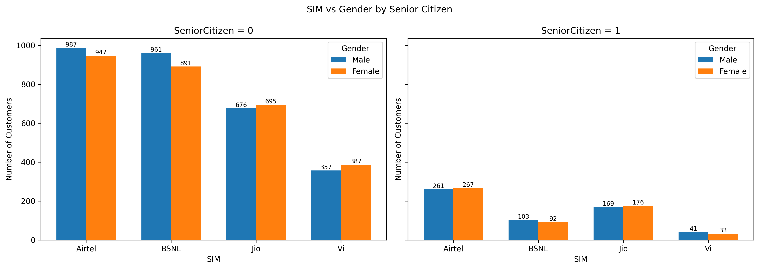
- Non senior customers are the majority in usage of all sims.
- Airtel and BSNL have the highest customer counts non senior citizen.
- The Gender distribution is nearly balanced at every SIM portion.
- Jio and Airtel have slightly more female users in non senior citizens.
- BSNL and Vi have lower senior citizen users.
- The below plot shows the Services percentage
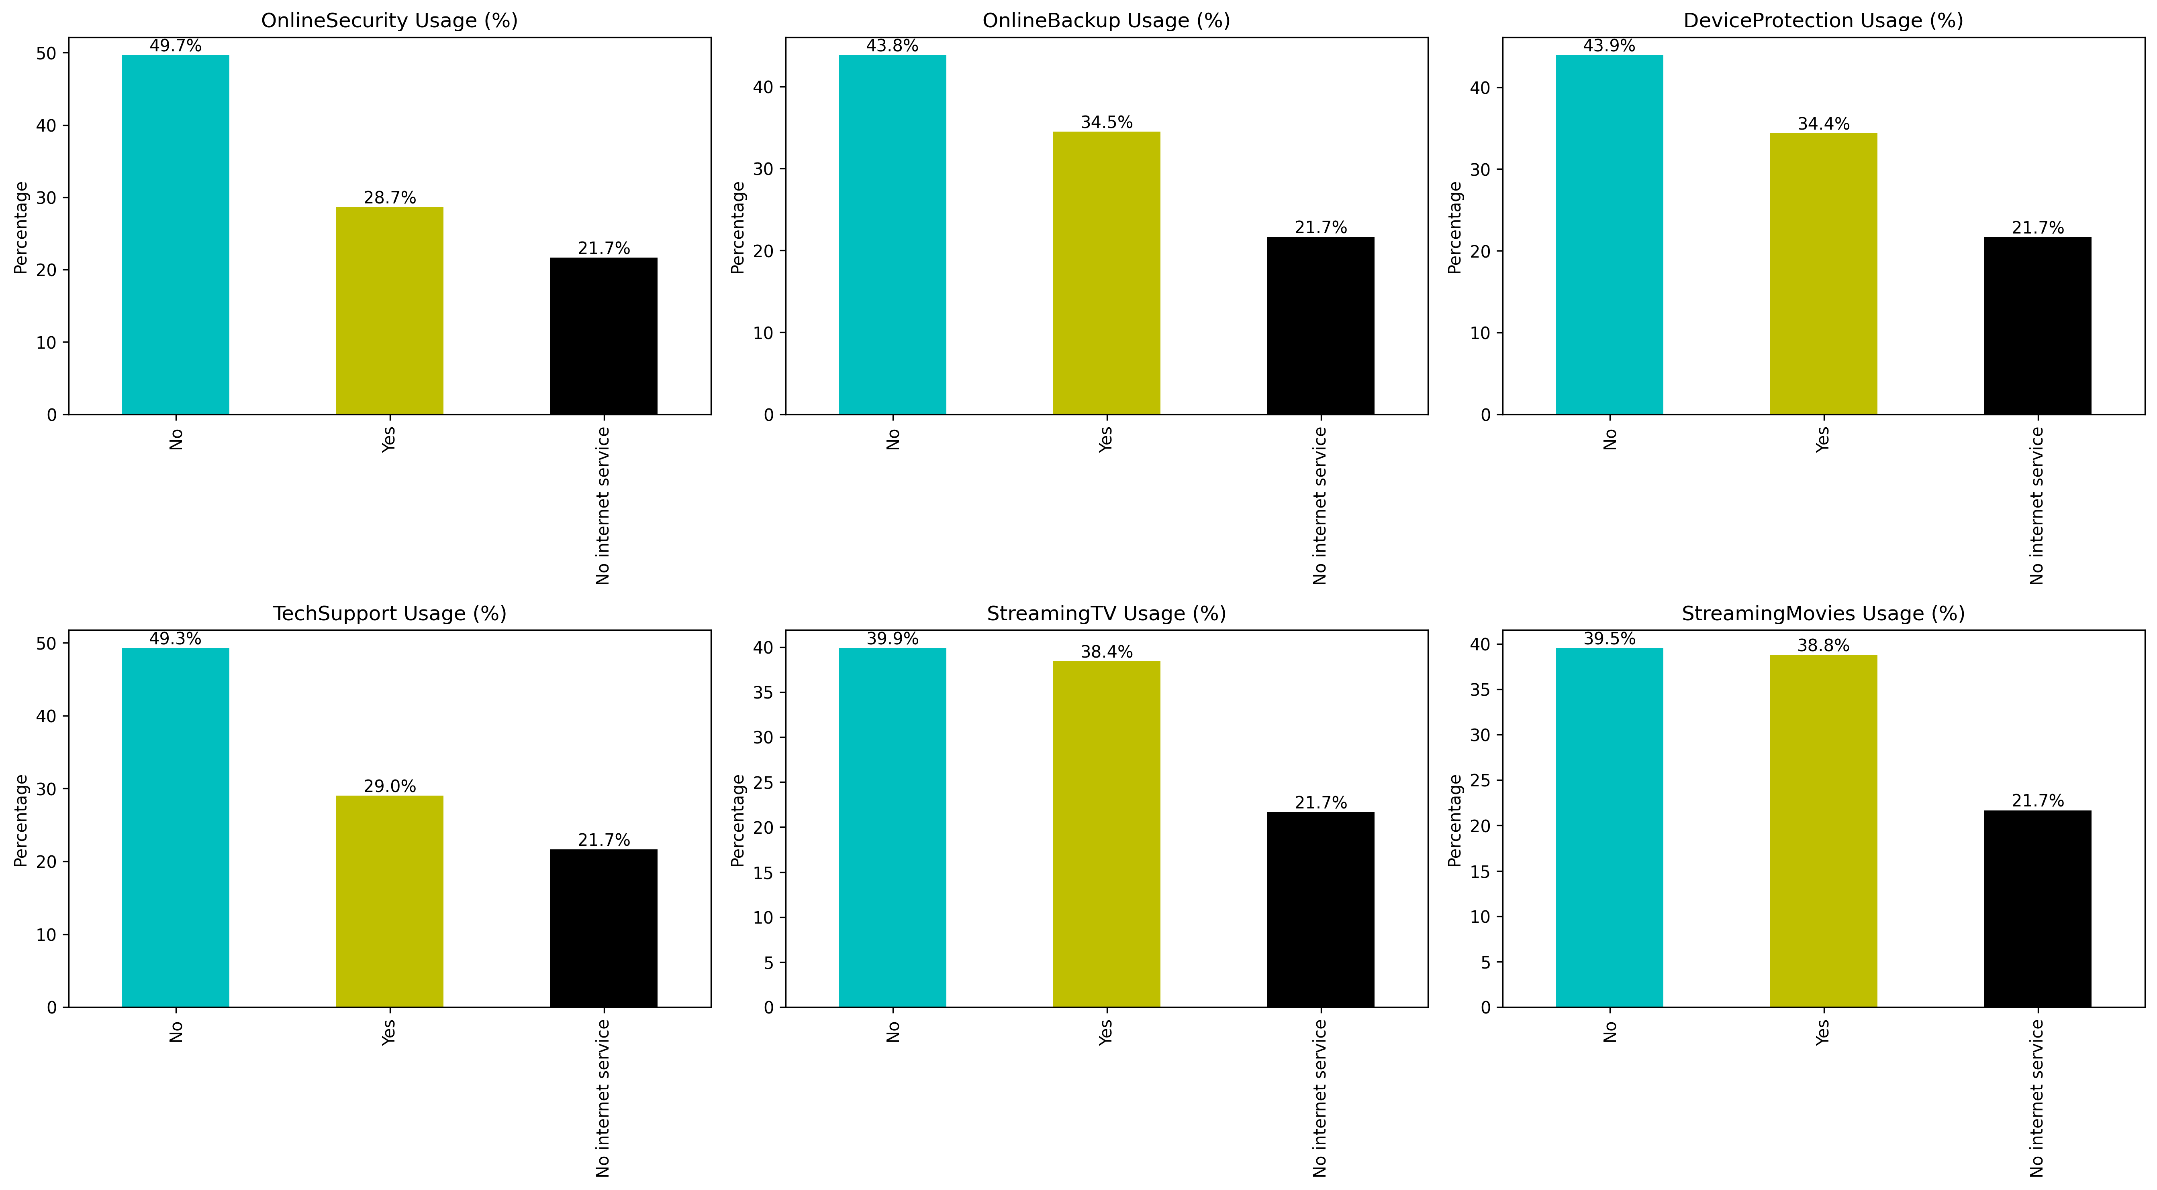
- A large portion of customers do not use services like Online Security, Backup, Device Protection, and Tech Support.
- Streaming services (TV & Movies) have higher users compared to security-related services.
- Customers with no internet service consistently having 21.7%, across all.
- Online Security and Tech Support have the lowest usage, indicating low adoption.
- Online Backup and Device Protection show moderate adoption levels.
- Streaming services have almost equal Yes and No usage, showing strong demand.
- The below plot shows the relation between Contract,Sim,Gender
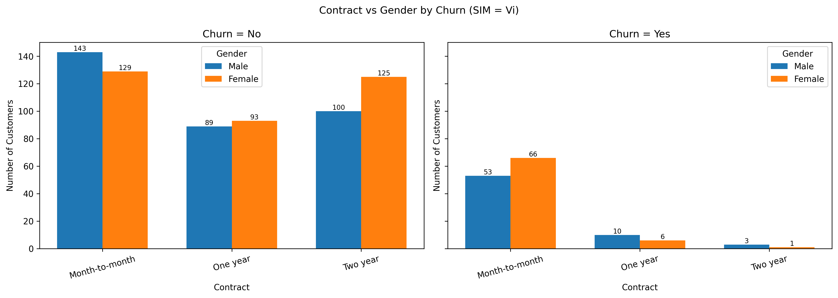
- Majority of customers are on Month-to-Month contracts.
- One-year and Two-year contracts have fewer customers compared to month-to-month.
- Female customers slightly dominate in two-year contracts.
- Gender distribution is fairly balanced across all contract types.
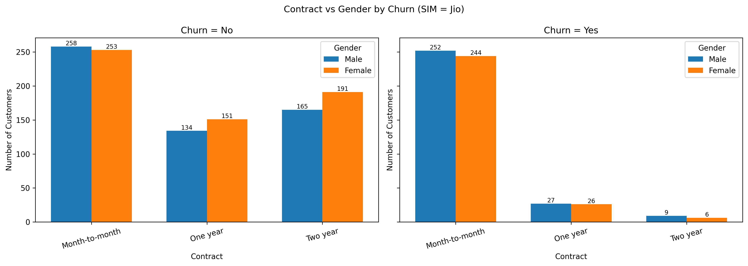
- Month-to-Month contracts have the highest customer count.
- Two-year contracts are more popular than one-year contracts.
- Female customers are slightly higher in long-term contracts.
- Gender distribution remains nearly equal overall.
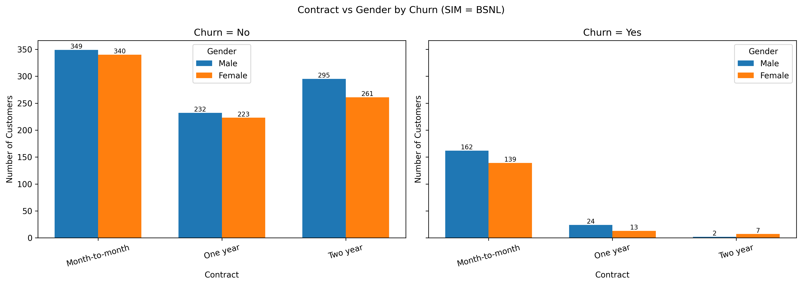
- Large number of customers are on Month-to-Month contracts.
- Two-year contracts have good adoption compared to one-year.
- Male customers slightly dominate across all contract types.
- Gender gap is small and consistent.
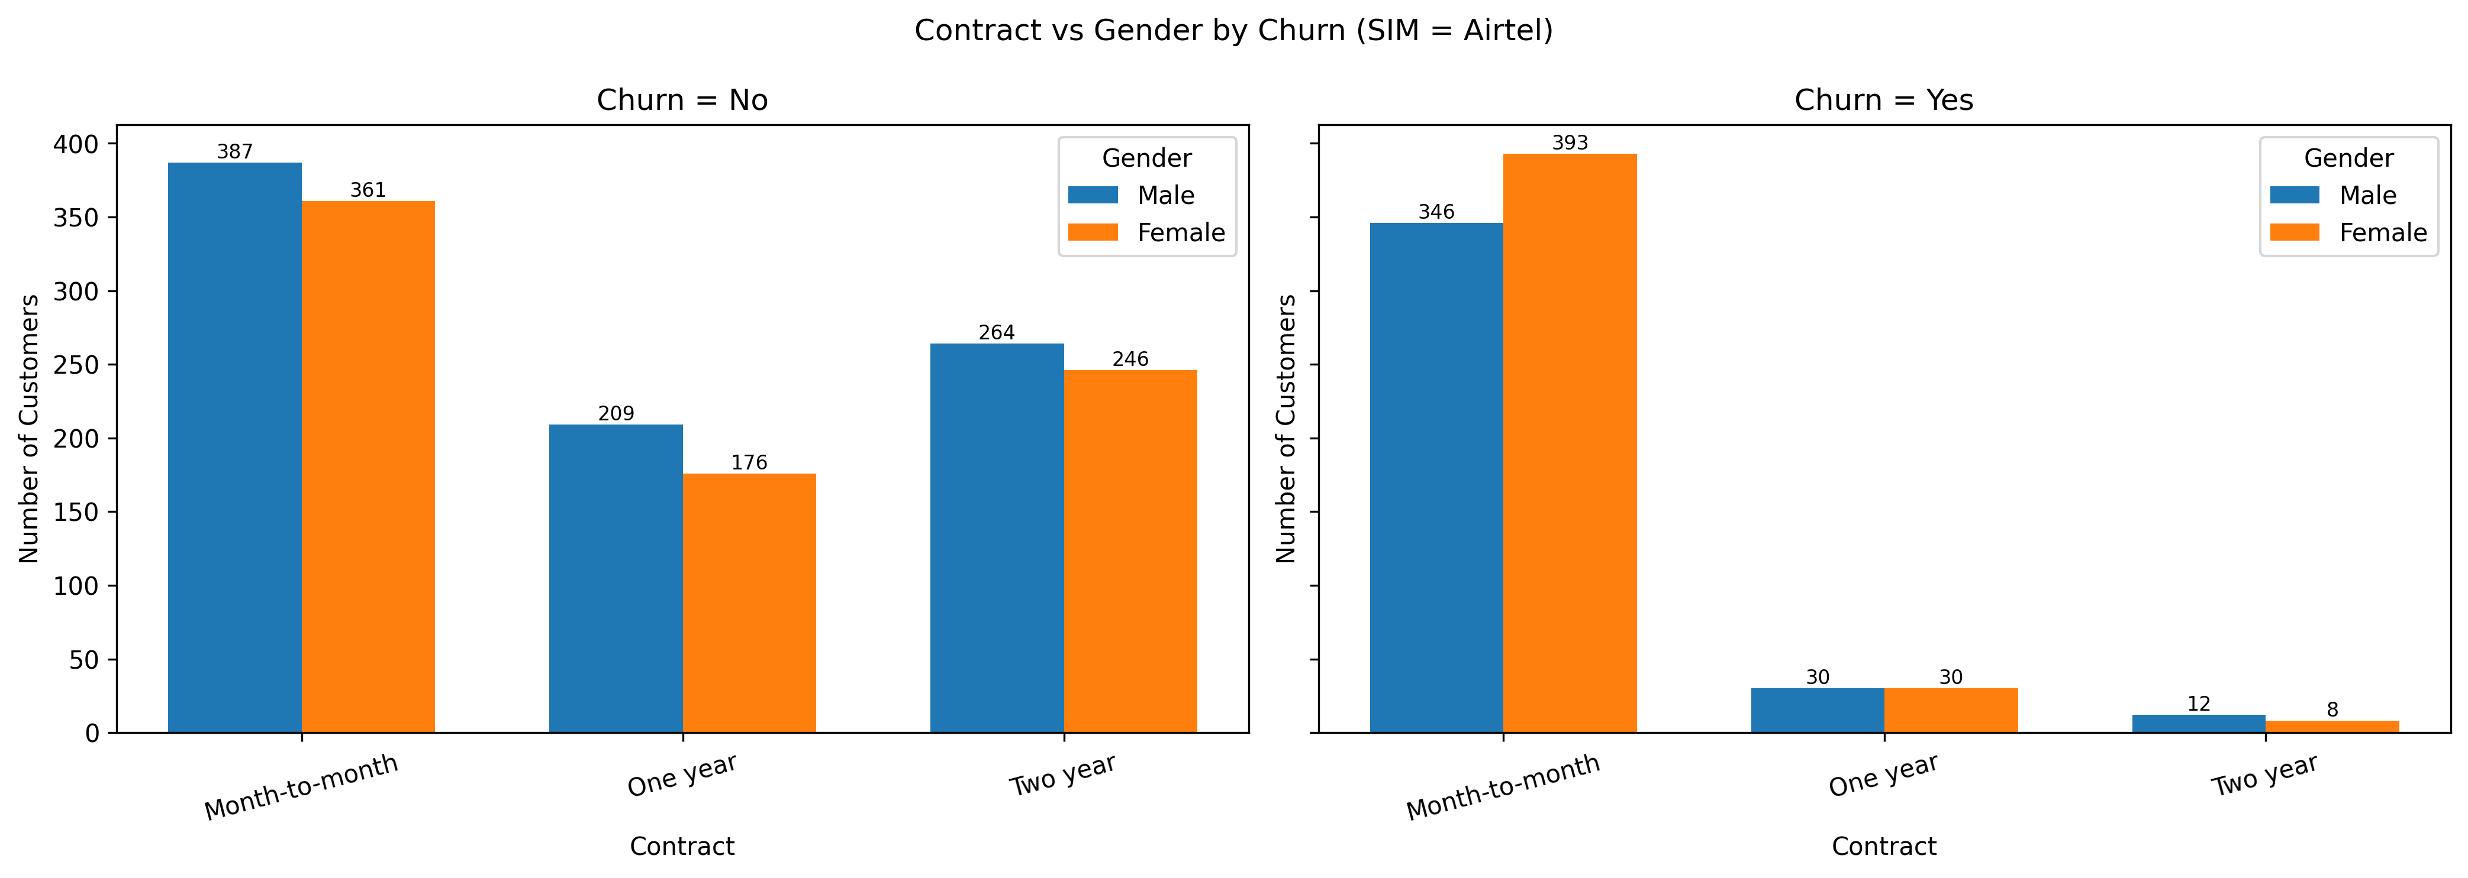
- Highest customer base across all contract types.
- Month-to-Month contracts dominate, followed by two-year contracts.
- Female customers slightly exceed males in month-to-month plans.
- Gender distribution is balanced in long-term contracts.

- The below plot shows the relation between Paperlessbilling,Gender,churn
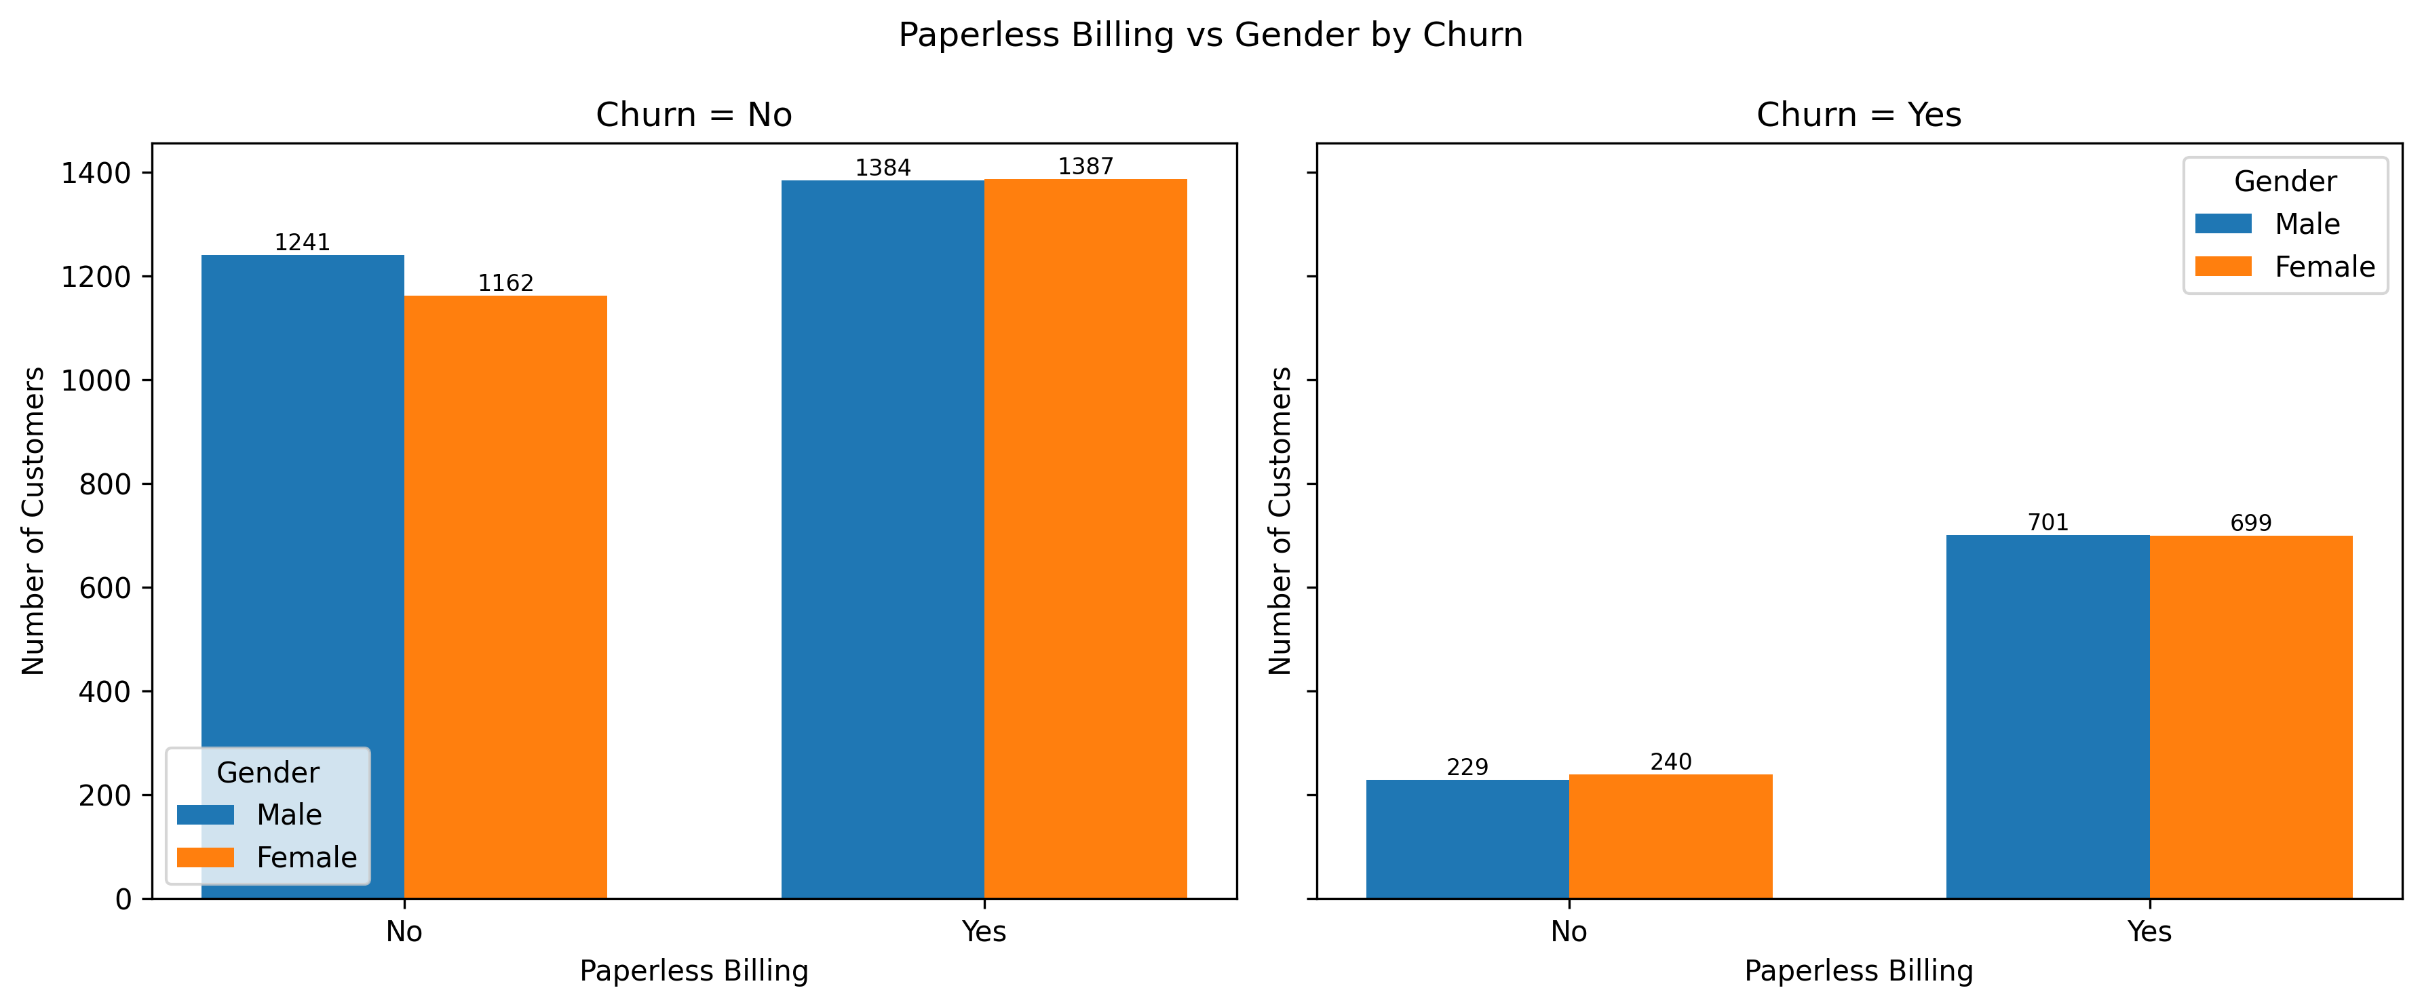
- Majority of customers use paperless billing.
- Male and female counts are almost equal.
- High adoption indicates strong acceptance of digital billing.
- Fewer customers prefer paper bills.
- Male customers slightly outnumber females.
- Traditional billing is becoming less popular.
- Both genders show similar digital adoption behavior.
- The below plot shows the relation between Payment Method,Gender,churn
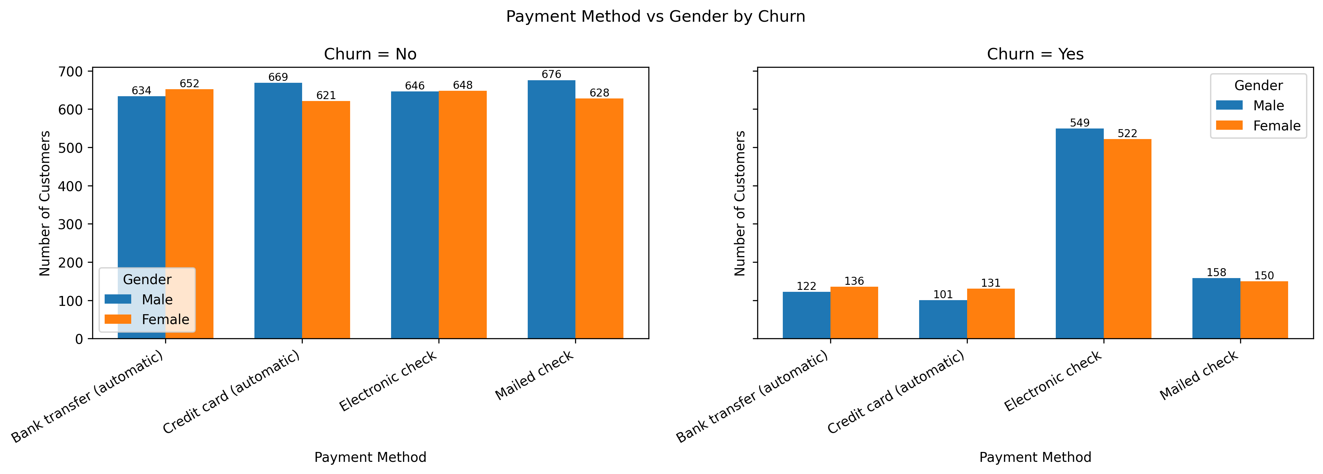
- Electronic Check is the most commonly used payment method across customers.
- Automatic payment methods (Bank Transfer & Credit Card) are widely adopted.
- Mailed checks are the least preferred payment option.
- Male and female customers show very similar payment behavior.
- No strong gender-based preference is observed for any payment method.
- Customers overall prefer digital and automated payment modes over traditional ones.

- The below plot shows the relation between Tenure,Sim,Gender,churn
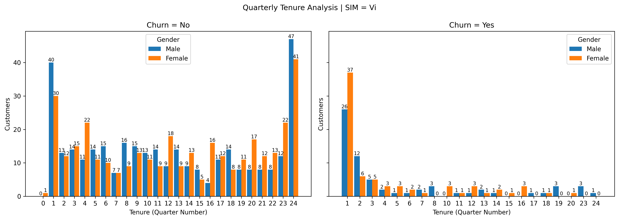
- Most customers are concentrated in early tenure quarters (1–3).
- Customer count drops sharply as tenure increases.
- Male and female distribution is fairly balanced across quarters.
- Very few long-tenure customers (after 16).
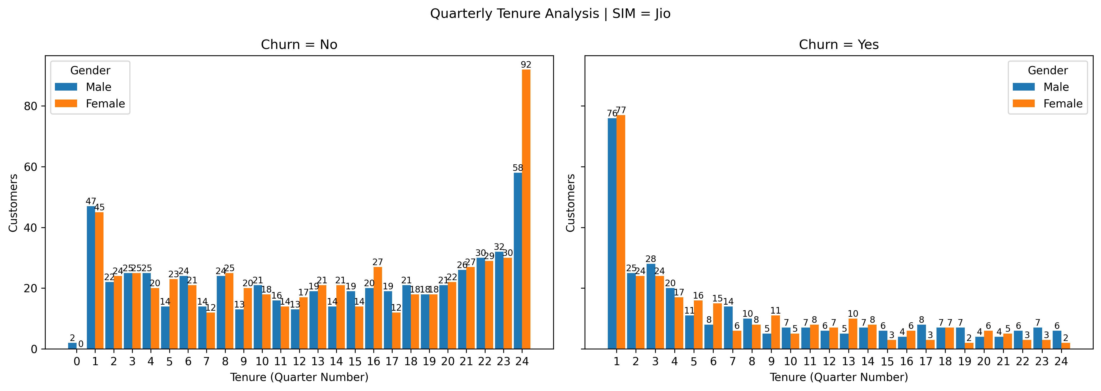
- Strong customer presence in early quarters, especially 1–4.
- Gradual decline in customers as tenure increases.
- Female customers slightly outnumber males in higher tenures.
- Some stability seen in mid-to-late tenure compared to Vi.
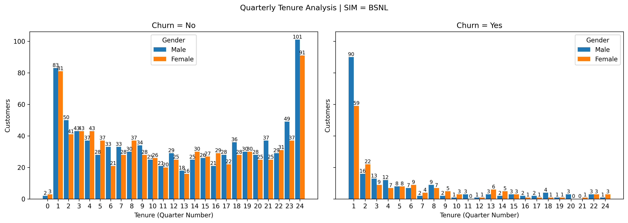
- High customer concentration at 1 and 24, showing legacy users.
- Strong presence in long-tenure customers.
- Male customers slightly dominate across most quarters.
- Consistent distribution across mid-tenure quarters.
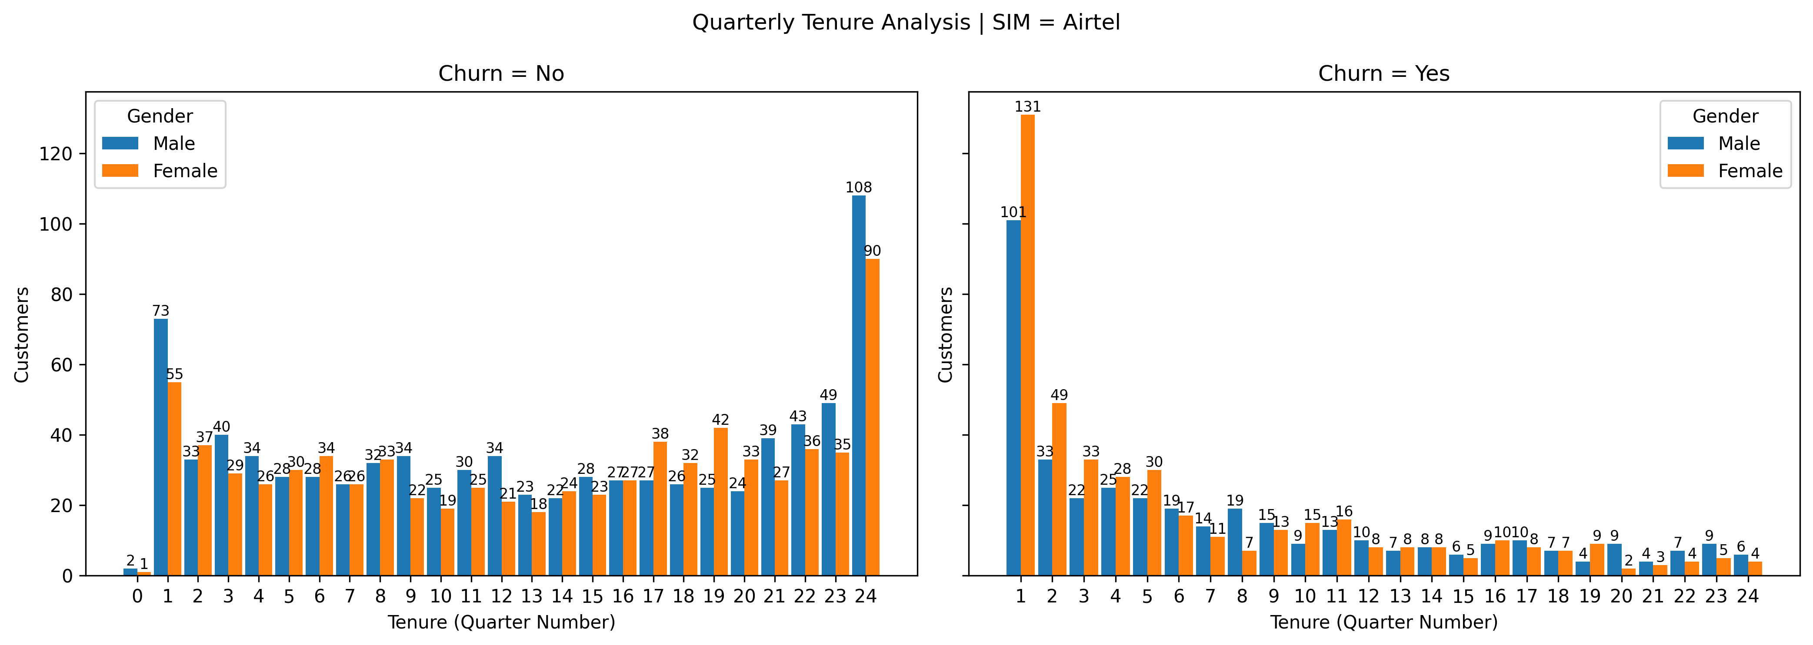
- Large number of customers in early tenure quarters.
- Good customer presence even in higher tenure quarters.
- Gender distribution is very balanced across tenure.
- Retains more customers long-term compared to Vi and Jio.

- The below plot shows the relation between Monthlycharges,Sim,churn
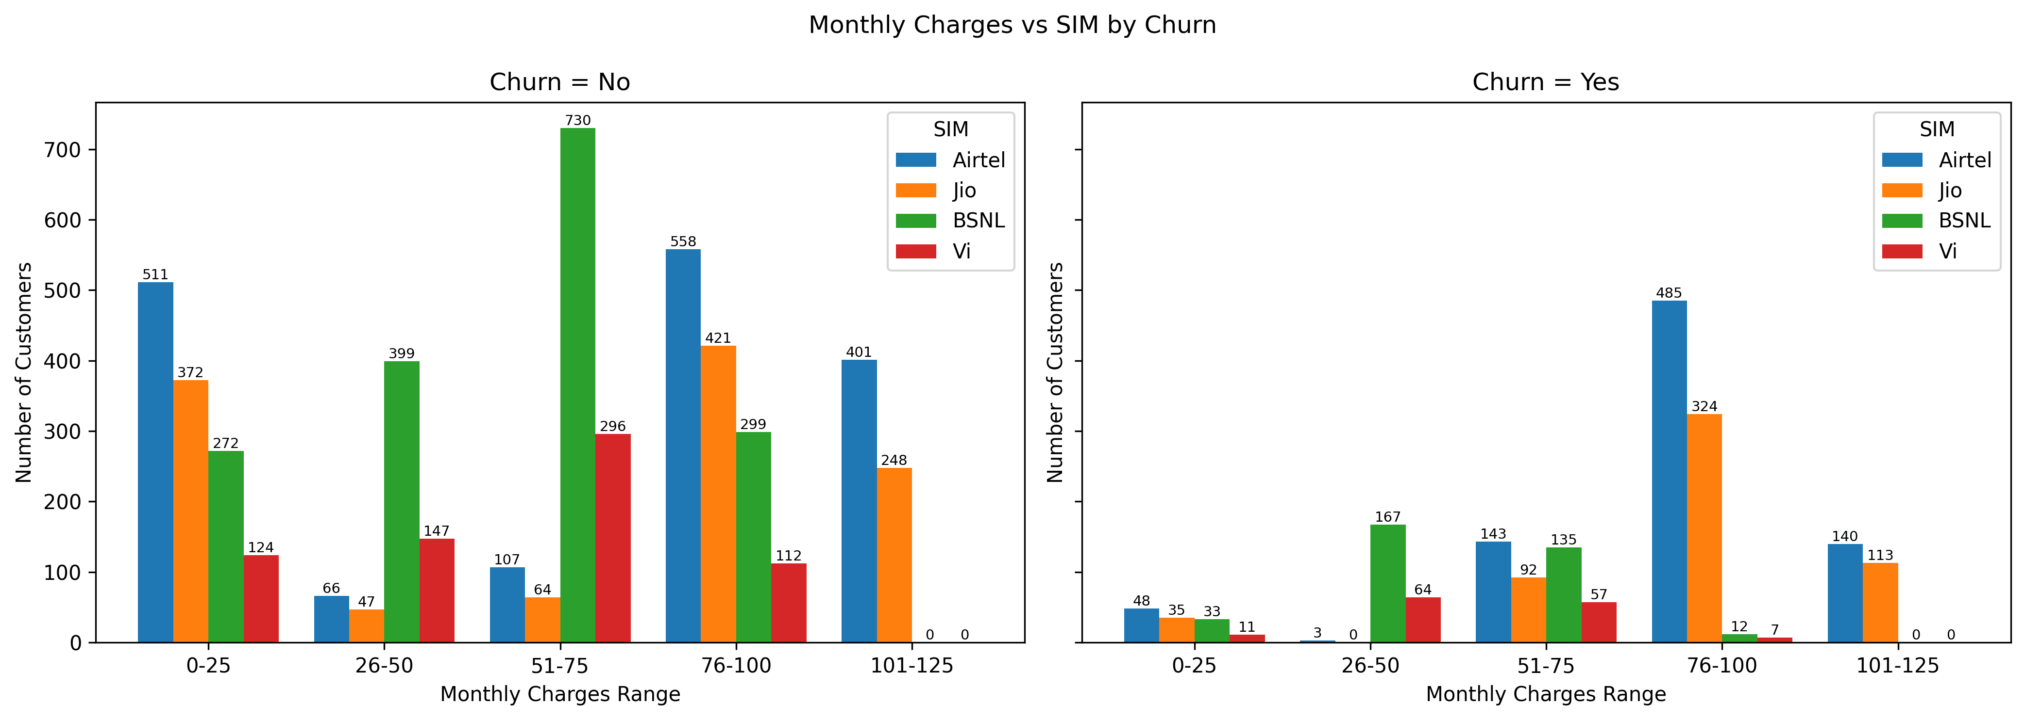
- 76–100 rupees range has the highest number of customers across most SIMs.
- Airtel and Jio dominate the higher monthly charge ranges (76–125)rupees.
- BSNL customers are concentrated in mid ranges (26–75)rupees.
- Vi has fewer high-paying customers, mostly in lower and mid ranges.
- Very few customers fall in the 101–125 rupees range, especially for BSNL and Vi.
- Lower charge range 0–25 rupees has noticeable presence but fewer premium users.
- The below plot shows the relation between Region,Gender,citizen,churn
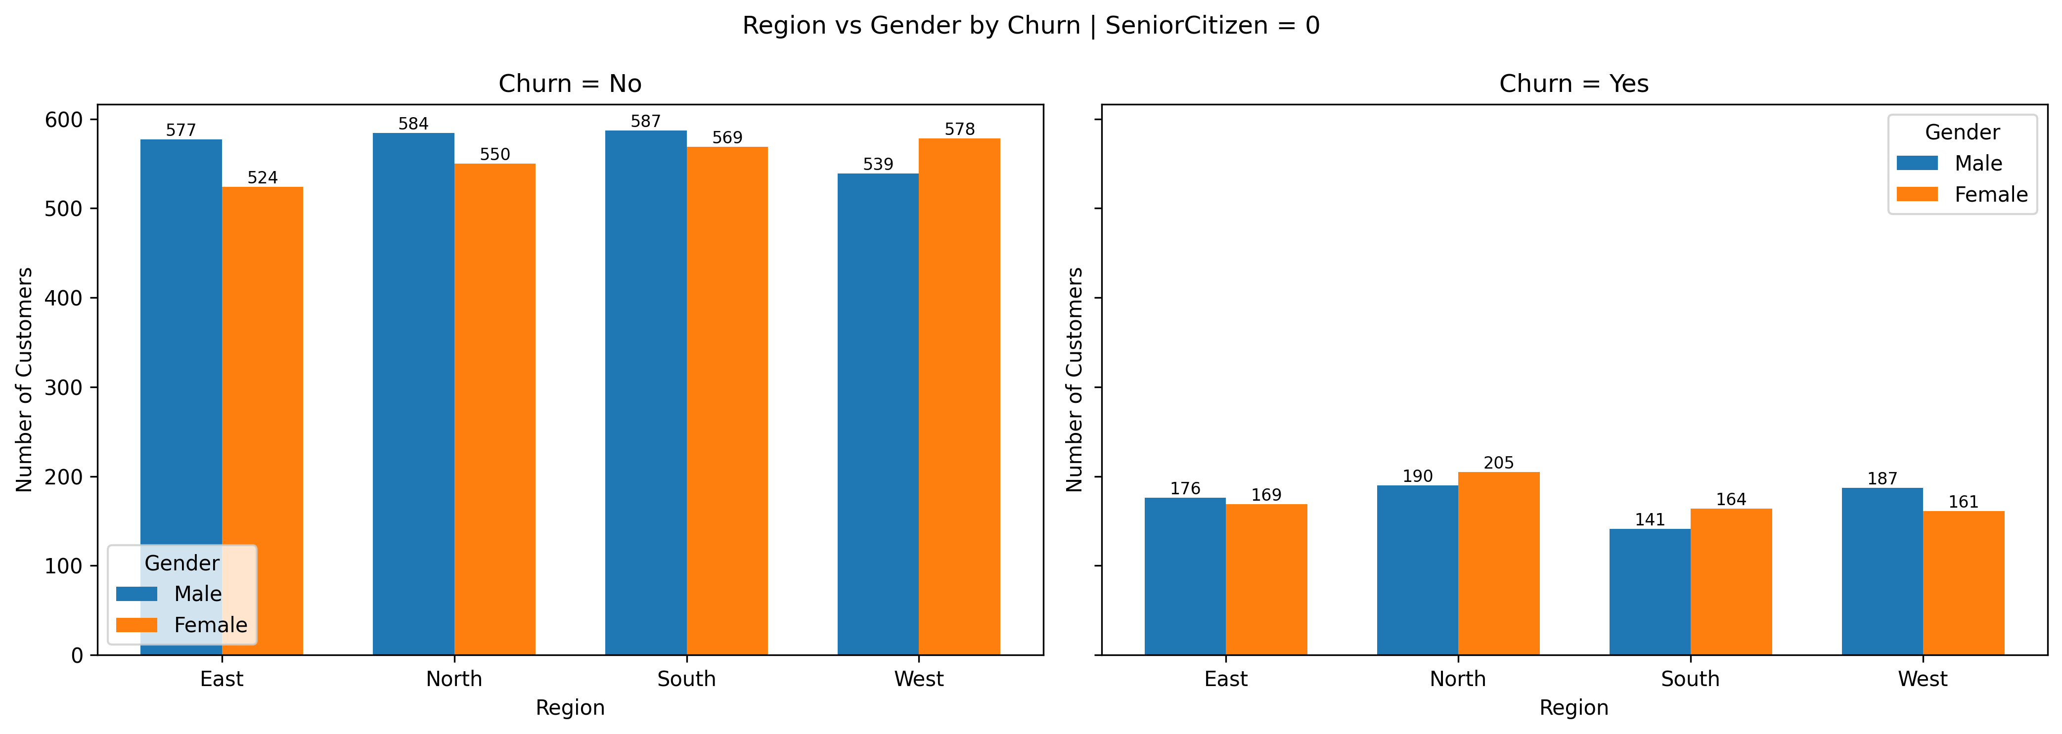
- Non-senior customers are highest in South and North regions.
- West region also has a strong non-senior customer base.
- East has comparatively lower customer count.
- Male customers slightly dominate in East, North, and South.
- Female customers slightly dominate in the West.
- Gender differences remain minor across all regions.
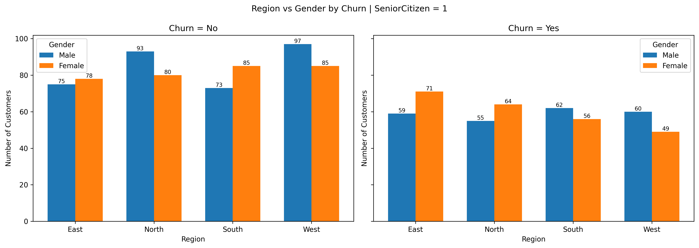
- Senior customers are evenly distributed across all regions.
- West and North regions have slightly higher senior customer presence.
- Gender distribution is balanced in every region.
- Female seniors are slightly higher in East and North.
- Male seniors slightly dominate in the West region.
- No region shows a strong gender imbalance.

4. OVERALL SUMMARY

Key Data Statistics
- Churn Rate: 26.5% (High churn risk) vs. 73.5% (Retained customers).
- Customer Base: 7,043 total customers analyzed.
- Gender Distribution: Nearly balanced (Male ~50.5%, Female ~49.5%).
- Service Providers: Jio (largest customer base), followed by Airtel, BSNL, and Vi.
Based on the complete analysis of all visualizations, the following are the core drivers of customer churn:

A. The “Early Tenure Churn” Effect
The most critical insight comes from tenure-based analysis.
A very large proportion of churn occurs within the first 0–6 months of customer lifecycle. Customer counts drop sharply after early quarters, especially among churned users. Once customers cross one year of tenure, churn reduces drastically and stabilizes.

B. Contract & Payment Friction
- Contract Type:
Customers on Month-to-Month contracts show the highest churn rates across all service providers.
In contrast, 1-Year and 2-Year contract customers are highly stable, with very low churn.
- Payment Method:
Electronic Check users churn the most, even though it is the most commonly used payment method.
Customers using automatic payments (Credit Card / Bank Transfer) show strong retention and very low churn.

C. Service-Specific Issues
- Fiber Optic Internet:
Although Fiber Optic is the most widely used service, it also experiences significantly higher churn compared to DSL and No-Internet users. This indicates potential pricing concerns or service quality issues.
- Low Adoption of Value-Added Services:
Services like Online Security, Tech Support, Backup, and Device Protection have very low usage rates despite being strong retention drivers.
Streaming services show better adoption, but security-related services are underutilized.

D. Demographic & Regional Insights
- Senior Citizens:
Senior citizens churn at a noticeably higher rate compared to non-senior customers across regions and services.
- Gender:
Gender shows no meaningful impact on churn. Male and female customers behave almost identically across contracts, services, regions, and payment methods.
- Region:
Churn patterns are consistent across regions, with no region showing extreme imbalance. Regional differences are minor and secondary compared to tenure and contract effects.

Final Business Takeaway
Customer churn is not random. It is strongly driven by:
- Early tenure dissatisfaction (0–6 months)
- Flexible Month-to-Month contracts
- Manual payment methods (Electronic Check)
- Fiber Optic service challenges
- Low adoption of retention-focused add-on services

